**EXPERIMENT-5:**

**1. Aim:**

**Implementation of a Switch Using Packet Tracer**

**2. Apparatus (Software):**

* **Command Prompt** (for basic network commands like ping, ipconfig, etc.)
* **Cisco Packet Tracer** (for network simulation)

**3. Procedure:**

Below are the step-by-step instructions to implement a switch using Packet Tracer:

**Step 1: Launch Packet Tracer**

* Open Cisco Packet Tracer on your computer.
* Start a new project by clicking on File > New.

**Step 2: Add Devices to the Workspace**

* **Switch**: From the device type list, select the Switch category and choose a switch (e.g., 2960). Drag and drop it into the workspace.
* **End Devices**: Select the End Devices category and drag two or more PCs (e.g., PC-PT) into the workspace. These will be the devices connected to the switch.

**Step 3: Connect Devices**

* Use the Connections icon to select a Copper Straight-Through cable (solid black line).
* Connect each PC to the switch by clicking on the PC, selecting FastEthernet0, and then clicking on the switch's interface (e.g., FastEthernet0/1, FastEthernet0/2, etc.). 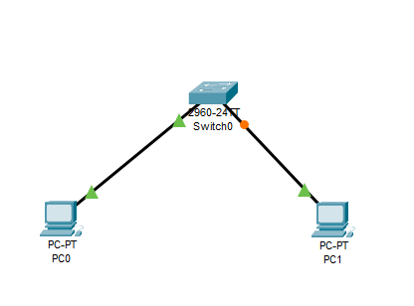

**Step 4: Configure IP Addresses**

* Click on each PC and go to the Desktop tab.
* Open the IP Configuration tool.
* Assign an IP address to each PC within the same network. For example:
  + **PC1**: IP Address: 192.168.1.2, Subnet Mask: 255.255.255.0
  + **PC2**: IP Address: 192.168.1.3, Subnet Mask: 255.255.255.0

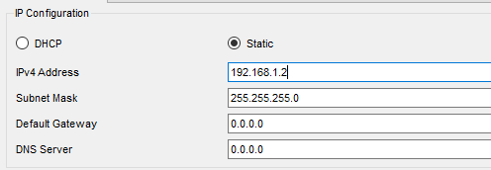

**Step 5: Verify Physical Layer Connectivity**

* Click on the Simulation mode (bottom right).
* Add a Simple PDU from Add Simple PDU (envelope icon) and click on one PC and then on the other. This will create a ping command.
* Run the simulation to ensure the PCs are physically connected and can communicate at the physical layer.

**Step 6: Test Network Connectivity**

* 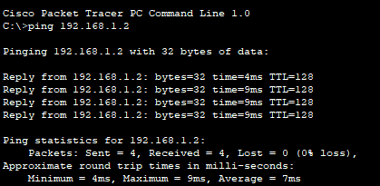Return to Real-Time mode (bottom right).
* Open the Command Prompt on each PC by going to Desktop > Command Prompt.
* Use the ping command to test the network connection between PCs:
* Use ping command to check the Connection .

**Step 7: Observe Switch Operation**

* Notice that the switch forwards packets only to the correct destination port, not to all ports (unlike a hub).
* The switch uses MAC addresses to determine where to send the data, ensuring efficient network traffic management.

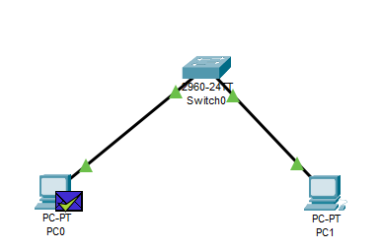

**Step 8: Save the Configuration**

* Save your Packet Tracer project by selecting File > Save As and choosing a location on your computer.

**Step 9: Additional Configuration (Optional)**

* For advanced configurations, you can set VLANs, configure the switch using the CLI, and implement trunking between switches.
* Use the CLI of the switch by clicking on it and selecting the CLI tab. Here, you can configure various switch settings.

**Step 10: Document the Experiment**

* Record your observations, noting how the switch manages network traffic and any differences observed when using different topologies or configurations.